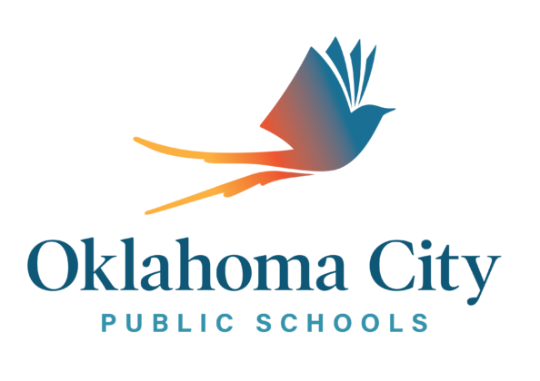

**AGENDA**

**Oklahoma City Public Schools – Oklahoma City Elementary**

**Title I Annual Parent Meeting**

**Auditorium**

Date:

Time:

**2020-2021 Title I Program**

1. Title I Overview
   * Federal funding source for low-achieving students
   * Two models of support and intervention used to operate a Title I program –Comprehensive and Targeted: All students receive services at (name of school). Our school is a Title I schoolwide site.
   * Allocation amount determined by the site’s free and reduced lunch count
   * Details about Title I program-enter information for your site’s program based on the plan
2. District Level Parental and Family Engagement Policy Oklahoma City Public Schools website.
3. Site Level Parent and Family Engagement Policy
4. Parent’s Right to Know Letter
5. Family – School Compact
6. Schoolwide Improvement Plan (SWP) and Continuous School Improvement Plan (CSI –CIP) for in GMS (Grant Management System), if it applies to your site. A comprehensive needs assessment plan for the school must in place to spend Federal Title I dollars.
7. OAS Academic Standards

⬥ Developed by the Oklahoma State Department of Education (OSDE)

⬥ Outline expectations for what students need to know and be able to do by the end of the school year.

Grade level standards can be assessed through the State Department of Education website.

8. How can parents help?

**Questions and Answer Session**