January 23, 2019  
  
Dear Taft families & staff,   
  
For the last year, OKCPS has been moving forward on our "Pathway to Greatness" as we follow through on our commitment to reinvent our District. Our highest priority must be serving our students equitably and ensuring access to more educational opportunities and support services -- regardless of their zip code. We believe this work will enable our students to achieve the OKCPS vision of every student graduating ready to fulfill their unique purpose in a healthy, vibrant community.   
  
Yesterday, Superintendent McDaniel advised me that Taft Middle School will be reconfigured to serve grades 5-8.

If you were unable to attend or view the Board of Education Work Session which is being held at Northeast Academy tonight at 5:30pm, I encourage you to watch a playback of the livestream from the meeting (https://www.youtube.com/channel/UCcyRYC8sjI0VI0cilAOvZ_g/live), or attend one or more of the 5 community meetings being held around the District.

* January 23 at US Grant High School | 6 pm
* January 24 at US Grant High School | 6 pm *Presented in Spanish
* January 28 at Star Spencer High School | 6 pm
* January 29 at Douglass High School | 6 pm
* January 30 at NW Classen High School | 6 pm

When we met, Dr. McDaniel reiterated, “Although the next few months will be hard and change is certain, the Board and I are confident that this work is necessary to improve the health of the entire OKCPS system and to provide equity and opportunity for our students. Now more than ever, we must all come together and focus on the future. Our students deserve it and our city's long-term success depends on it.”  
  
Change is hard, but we know that the status quo is not giving all students what they need right now. Through the Trade-Ups associated with the Pathway To Greatness, our children will have access to more learning opportunities and to added social supports like counselors. Our teachers will be better supported too with trade-ups like smaller class sizes in grades K to 6th. We will be working to match community partners to use our repurposed buildings for community health centers, early childhood centers, and other kinds of positive assets to our neighborhoods.  
  
I don’t have all the answers yet, but we will get through this together. Regardless of the outcome of this Pathway to Greatness work, please rest assured that OKCPS will continue to serve and support every child.  
  
It’s important to stay informed as OKCPS completes this process. Please stay engaged, connected and provide feedback regarding these options. Every school in the District will be impacted in some way.  
  
Thank you for your continued support of Taft Middle School and OKCPS.   
  
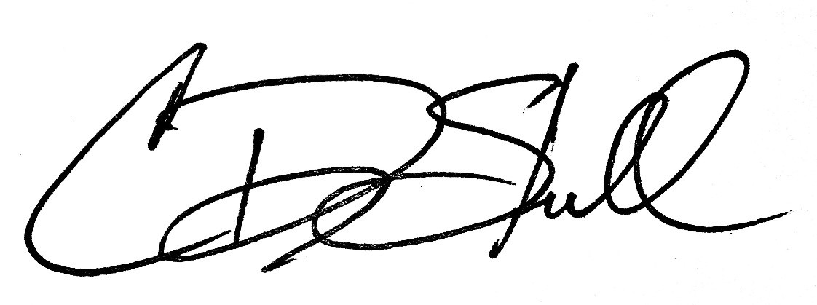

Cody Stull

Principal  
Taft Middle School