**US Grant High School Uniform Policy 2018-2019**

**SHIRTS:** Long or short-sleeve, with or without collars (crew neck only), plain, in **SOLID** colors of red, grey, black, or white **ONLY** may be worn. Logos, insignias, or other markings must not be larger than a quarter. No V-neck or scoop-neck style shirts.

[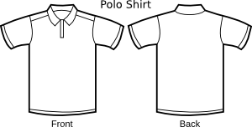](javascript:edit(17277)) 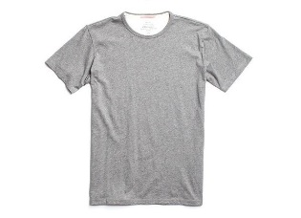 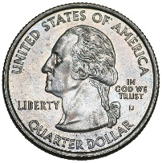

**SPIRIT SHIRTS:** Spirit shirts may be worn on any day. Approved spirit shirts must be affiliated with the school in some manner and may say “US Grant” or “Grant” or “Generals”. Spirit shirts must be red, gray, black, or white in color. Spirit shirts **DO NOT** include blood drive shirts, tournament shirts, GEAR-UP shirts not in red, gray, black, or white, and cannot be designed/created by a student at home and worn to school. Spirit shirts are available for purchase throughout the year through a variety of class sponsorships, group activities, clubs, sports teams, andgroups.

**UNDERSHIRTS:** Undershirts, if worn, must be a solid color of red, grey, black or white.

**JACKETS OR ZIPPERED SWEATSHIRTS:** May be worn, but must be open with uniform shirt visible.

**SWEATSHIRTS WITH OR WITHOUT A HOOD:** US Grant sweatshirts or sweatshirts in a **SOLID** color of red, grey, black or white only may be worn throughout the school day. No other emblems or writing will be allowed.

**PANTS:** Khaki pants only. No holes, rips, tears, or shreds. Pants must fit and not sag. Belts may be worn, but may not be military style or have a military buckle. Belt buckles should not be any emblem that would be inappropriate for school. Belt buckles should not be larger than a credit card in size. The belt buckle may not have any letters or initials carved into it.  
  
 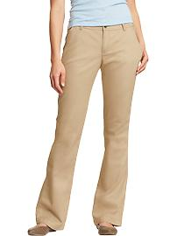 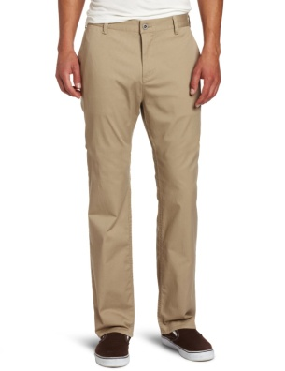  
  
**SHOES:** No flip flops, shower shoes, sliders, or house shoes/slippers.

**HATS:** No hats of any kind may be worn in the school building.

**STUDENTS MUST ALSO STAY IN COMPLIANCE WITH THE DISTRICT DRESS CODE AS  
STATED IN THE OKCPS STUDENT/PARENT HANDBOOK**