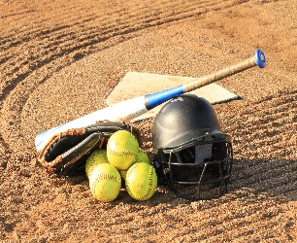

**BIEMS Softball 2024**

Aug 27th Tues Belle Isle vs. Classen SAS Away

Location Classen SAS H.S. 5:30 pm

Aug 29nd Thurs Belle Isle vs. Taft Away

5:30 pm

Sept 5th Thurs Belle Isle vs. Capitol Hill Away

At CHHS 5:30 pm

Sept 9th Mon Belle Isle vs. Roosevelt Away

5:30 pm

Sept 12th Thurs Belle Isle vs. Western Heights Away

At JMMS 5:30 pm

Sept 19th Thurs Belle Isle vs. Wheeler Away

At CHHS 5:30 pm

Sept 23rd Mon Belle Isle vs. Southeast Away

At SEHS 5:30 pm

Oct 7th & 8th ACAC Tournament