**BIEMS Baseball 2025**

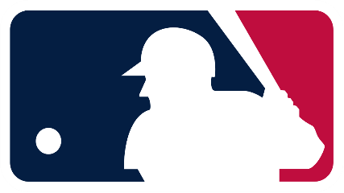

[This Photo](https://en.wikipedia.org/wiki/Major_League_Baseball_logo) by Unknown Author is licensed under [CC BY-SA](https://creativecommons.org/licenses/by-sa/3.0/)

March 13th Monday Belle Isle vs. Western Heights Away 5:30 pm

March 27th Thursday Belle Isle vs. Jefferson Away

5:30 pm

April 1st Tuesday Belle Isle vs. Webster at Wheeler

5:30 pm

April 3rd Thursday Belle Isle vs. Rogers at Star Spencer

5:30 pm

April 8th Tuesday Belle Isle vs. Roosevelt at Roosevelt

5:30 pm

April 15th Tuesday Belle Isle vs. Classen SAS at Dolese Park

6:00 pm

April 17th Thursday Belle Isle vs. Southeast at Southeast

5:30 pm

April 22nd Tuesday Belle Isle vs. Taft at NW HS

5:30 pm

ACAC Tournament

April 24th Thursday Belle Isle at Individual Sites

April 28th Monday Location TBD