**Charter School Closure Plan**

**OSDE Charter Law Checklist for School Closure**

❑ Written notification 8 months before contract expiration around intent.

❑ Within two weeks of board decision, sponsor meets with charter leadership to establish transition team*.

❑ Transition team communicates regularly and effectively with stakeholders: students, parents, staff, etc. about closure, options and risks.

❑ Transition team ensures that instruction continues until the contract expires.

❑ Transition team ensures that notification is made to the following: agencies, employees, insurers, contractors, creditors, debtors, and the like.

❑ Charter board meets to take necessary action needed to wind down school operations, manage finances, allocate resources and facilitate all aspects of closure.

❑ Timely notification around revocation provided to charter with reasons outlined.

❑ Allow charter response time.

❑ Allow charter opportunity to submit documents and give testimony in public hearing challenging rationale for closure.

❑ Allow charter access to representation by counsel to call witnesses on its behalf.

❑ Provide a clearly stated resolution for closure.

❑ Written notification 8 months before contract expiration around intent.

❑ Written notification 8 months before contract expiration around intent.

*Transition Team may include: school staff, applicant staff, others designated by applicant to include those responsible for transfer of students, student records and school funds.

**School Closure Tasks by Targeted Category: Immediate Action, Notification, Records, and Financials**

|  |  |  |
| --- | --- | --- |
| **Action Items** | **Suggested Timeline** | **Champion** |
| Immediate Actions | | |
| Secure financial records | Within 24 hours of board vote | Charter school financial lead |
| Create and distribute press release | Within 24 hrs. of board decision | Authorizer Lead, Charter School board chair |
| Create charter school closure FAQ’s | Prior to school board vote to close school | Authorizer Lead |
| Distribute initial closure letter to parents and school | Within 24 hrs of board decision to close school | Authorizer Lead, Charter School board chair |
| Send initial closure notification letter to state and local agencies | Within 24 hrs. of board decision | Authorizer Lead, Charter School board chair |
| Draft talking points for parents, faculty, community and press | Within 24 hrs. of board decision | Authorizer Lead, Charter School board chair |
| Gather parent contact information (name, address, phone and email) | Within 24 hours of board vote | Charter School Administrator Lead |
| Continue current instruction | Continuous | Charter school administrator lead |
| Secure Student Records | Within 24 hrs of board vote | Charter school administrator lead |
| Establish transition team and assign roles | Within 24 hrs of board decision to close school | Authorizer Lead, Charter School board chair |
| Assign transition team action item responsibilities | Within 48 hrs of board decision to close school | Authorizer Lead, Charter School board chair |
| Gather faculty contact information (name, position, address, phone and email) | Within 24 hours of board vote | Charter school faculty lead |
| Convene parent closure meeting  Provide:  -FAQ’s  -Board closure policy and vote  -Calendar for important dates for parents  -Specific remaining vacation days for students  -Present timeline for transitioning students  -Present timeline for closing down school operations  -Provide contact information if help is needed | Within 72 hrs of board vote | Authorizer Lead,  Charter school administrator Lead, Parent Lead |
| Convene Faculty/Staff Meeting  Board Chair to Communicate:  -commitment to continuing school operations during transition  -plan to assist students and staff in making choices  -reasons for closure  -transition timeline  -compensation and benefits timeline  -contact information for ongoing questions | Within 72 hrs of board vote | Charter school administrator Lead, Parent Lead, Charter Board Chair |
| Use of reserve funds | Within one week of board vote | Authorizer, Charter Board Chair, Charter School Financial Lead |
| Maintenance of Location and Communication  (maintaining location and telephone services) | Ongoing until full closure | Charter Board Chair |
| Insurance  (Assets belonging to others must be protected against theft, misappropriation and deterioration) | Ongoing until full closure | Charter Board Chair, Charter School Financial Lead |
| Notifications | | |
| Parent/guardian closure transition letter | Within ten days of board decision | Charter Board Chair, Charter School Admin Lead |
| Staff/faculty closure transition letter | Within ten days of board decision | Charter Board Chair |
| Agency Notifications | Within ten days of board decision | Authorizer Lead and Charter Board Lead |
| Notification of Employees Benefits Providers | Within 45 days of board decision | Charter Board Chair, Charter Financial Lead |
| Notification of Contractors Agreement | Within 3 weeks of board decision | Charter School Financial Lead |
| Notification to Creditors and Debtors | Within one month of board decision | Charter School Financial Lead |
| Records | | |
| Final Report cards and student records notice | One week after classes end | Faculty Lead, Charter Admin Lead |
| Transfer of Student Records | Within one month of classes ending | Charter Parent Lead, Charter Admin Lead, Charter Faculty Lead |
| Documenting Transfer of Student Records | Within one month of classes ending | Charter Board Chair, Charter Admin Lead |
| Transfer Testing Materials | One week after classes end | Charter Admin Lead |
| Financial | | |
| US Dept of Education Filing | One week after classes end | Charter Financial Lead |
| IRS Status | TBD | Charter Board Chair and Charter Financial Lead |
| Audit | Within 120 after classes end | Charter Board Chair and Charter Financial Lead |
| Vendors  (cancel contracts and agreements) | Within 45 days of board vote | Charter Financial Lead |
| Inventory | Within 45 days of board vote | Charter Financial Lead |
| Disposition of Property  (specifically accounting for items purchased with federal funds) | Within 45 days of board vote | Authorizer, Charter Financial Lead |
| Disposition of Inventory  -Establish plan (i.e., auction)  -Establish payment process (i.e., cash, checks, etc.) for remaining items | Within 45 days of board vote | Charter Financial Lead |
| Payment of Funds  (work with Authorizer to prioritize payment strategy considering state and local requirements) | Plan completed within 45 days of board vote | Charter Financial Lead, Authorizer |
| Expenditure Reporting  FER and APR need to be completed | Within 45 days of board vote | Charter Financial Lead |
| Itemized Financials  Review, prepare and make available:  -fiscal year-end statements  -cash analysis  -list of compiled bank statements  -list of payables  -list of all unused checks  -list of all bank accounts  -list of petty cash | Within 30 days of board vote | Charter Financial Lead |
| Payroll Reports  To include:  -taxes  -retirement  -employee contracts | Within 30 days of board vote | Charter Financial Lead |
| List of creditors and debtors  -generated list of all creditors and debtors and any amounts accrued and unpaid to each. | Within 3 weeks of board vote | Charter Financial Lead |

**Actual School Closure Task Timeline**

**(from before BOE Decision to 120 Days after Classes End)**

|  |  |
| --- | --- |
| **Immediate Action Closest to BOE Meeting** | |
| **Task** | **Targeted Category** |
| Create charter school closure FAQ’s –PRIOR TO BOE MEETING | Immediate Actions |
| Solidify partners to function on Transition Team – PRIOR TO BOE MEETING | Immediate Actions |
| Use of reserve funds – WITHIN ONE WEEK OF BOARD DECISION | Immediate Actions |

|  |  |
| --- | --- |
| **Ongoing Action** | |
| **Task** | **Targeted Category** |
| Maintenance of Location and Communication  (maintaining location and telephone services) | Immediate Actions |
| Insurance  (Assets belonging to others must be protected against theft, misappropriation and deterioration) | Immediate Actions |

|  |  |
| --- | --- |
| **To be Completed within 24 Hours of Board Decision/Vote** | |
| **Task** | **Targeted Category** |
| Secure financial records | Immediate Actions |
| Create and distribute press release | Immediate Actions |
| Distribute initial closure letter to parents and school | Immediate Actions |
| Send initial closure notification letter to state and local agencies | Immediate Actions |
| Draft talking points for parents, faculty, community and press | Immediate Actions |
| Gather parent contact information (name, address, phone and email) | Immediate Actions |
| Secure Student Records | Immediate Actions |
| Establish transition team and assign roles | Immediate Actions |
| Gather faculty contact information (name, position, address, phone and email) | Immediate Actions |

|  |  |
| --- | --- |
| **To be Completed within 48 Hours of Board Decision/Vote** | |
| **Task** | **Targeted Category** |
| Assign transition team action item responsibilities | Immediate Actions |

|  |  |
| --- | --- |
| **To be Completed within 72 Hours of Board Decision/Vote** | |
| **Task** | **Targeted Category** |
| Convene parent closure meeting  Provide:  -FAQ’s  -Board closure policy and vote  -Calendar for important dates for parents  -Specific remaining vacation days for students  -Present timeline for transitioning students  -Present timeline for closing down school operations  -Provide contact information if help is needed | Immediate Actions |
| Convene Faculty/Staff Meeting  Board Chair to Communicate:  -commitment to continuing school operations during transition  -plan to assist students and staff in making choices  -reasons for closure  -transition timeline  -compensation and benefits timeline  -contact information for ongoing questions | Immediate Actions |

|  |  |
| --- | --- |
| **To be Completed within 10 Days of Board Decision/Vote** | |
| **Task** | **Targeted Category** |
| Parent/guardian closure transition letter | Notifications |
| Staff/faculty closure transition letter | Notifications |
| Agency Notifications | Notifications |

|  |  |
| --- | --- |
| **To be Completed within 3 Weeks of Board Decision/Vote** | |
| **Task** | **Targeted Category** |
| Notification of Employees Benefits Provider | Notifications |
| Generate list of creditors and debtors | Financials |

|  |  |
| --- | --- |
| **To be Completed within 30 Days of Board Decision/Vote** | |
| **Task** | **Targeted Category** |
| Itemized Financials  Review, prepare and make available:  -fiscal year-end statements  -cash analysis  -list of compiled bank statements  -list of payables  -list of all unused checks  -list of all bank accounts  -list of petty cash | Financials |
| Payroll Reports  To include:  -taxes  -retirement  -employee contracts | Financials |
| Notification to Creditors and Debtors | Notifications |

|  |  |
| --- | --- |
| **To be Completed within 45 Days of Board Decision/Vote** | |
| **Task** | **Targeted Category** |
| Notification of Employees Benefits Providers | Notifications |
| Vendors  (cancel contracts and agreements) | Financials |
| Inventory | Financials |
| Disposition of Property  (specifically accounting for items purchased with federal funds) | Financials |
| Disposition of Inventory  -Establish plan (i.e., auction)  -Establish payment process (i.e., cash, checks, etc.) for remaining items | Financials |
| Payment of Funds  (work with Authorizer to prioritize payment strategy considering state and local requirements) | Financials |
| Expenditure Reporting  FER and APR need to be completed | Financials |

|  |  |
| --- | --- |
| **To be Completed WITHIN One Month of Classes Ending** | |
| **Task** | **Targeted Category** |
| Transfer of Student Records | Records |
| Documenting Transfer of Student Records | Records |

|  |  |
| --- | --- |
| **To be Completed One Week after Classes End** | |
| **Task** | **Targeted Category** |
| Final Report cards and student records notice | Records |
| Transfer Testing Materials | Records |
| US Dept of Education Filing | Financials |

|  |  |
| --- | --- |
| **To be Completed WITHIN 120 After Classes End** | |
| **Task** | **Targeted Category** |
| Audit | Financials |
| IRS Status | Financials |

**State Law and District Policy on Charter School Closure**

**Charter School Act**

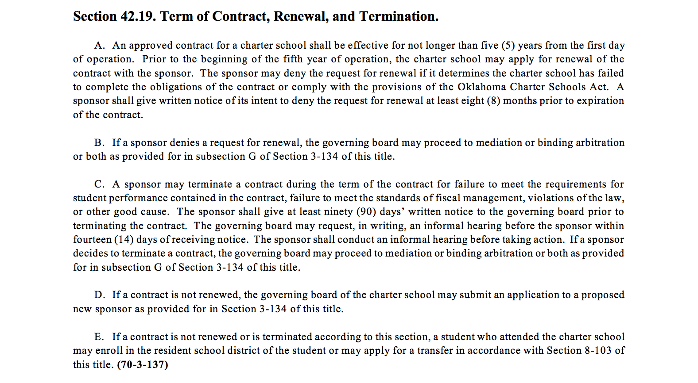

H. If a sponsor terminates a contract or the charter school is closed, the closure shall be conducted in accordance with the following protocol:

1. Within two (2) calendar weeks of a final closure determination, the sponsor shall meet with the governing board and leadership of the charter school to establish a transition team composed of school staff, applicant staff and others designated by the applicant that will attend to the closure, including the transfer of students, student records and school funds;

2. The sponsor and transition team shall communicate regularly and effectively with families of students enrolled in the charter school, as well as with school staff and other stakeholders, to keep them apprised of key information regarding the closure of the school and their options and risks;

3. The sponsor and transition team shall ensure that current instruction of students enrolled in the charter school continues per the charter agreement for the remainder of the school year;

4. The sponsor and transition team shall ensure that all necessary and prudent notifications are issued to agencies, employees, insurers, contractors, creditors, debtors and management organizations; and

5. The governing board of the charter school shall continue to meet as necessary to take actions needed to wind down school operations, manage school finances, allocate resources and facilitate all aspects of closure.

I. A sponsor shall develop revocation and nonrenewal processes that are consistent with the Oklahoma Charter Schools Act and that:

1. Provide the charter school with a timely notification of the prospect of revocation or nonrenewal and of the reasons for possible closure;

2. Allow the charter school a reasonable amount of time in which to prepare a response;

3. Provide the charter school with an opportunity to submit documents and give testimony in a public hearing challenging the rationale for closure and in support of the continuation of the school at an orderly proceeding held for that purpose and prior to taking any final nonrenewal or revocation decision related to the school;

4. Allow the charter school access to representation by counsel to call witnesses on its behalf;

5. Permit the recording of the proceedings; and

6. After a reasonable period for deliberation, require a final determination be made and conveyed in writing to the charter school.

J. If a sponsor revokes or does not renew a charter, the sponsor shall clearly state in a resolution the reasons for the revocation or nonrenewal.

K. 1. Before a sponsor may issue a charter to a charter school governing body that has had its charter terminated or has been informed that its charter will not be renewed by the current sponsor, the sponsor shall request to have the proposal reviewed by the State Board of Education at a hearing. The State Board of Education shall conduct a hearing in which the sponsor shall present information indicating that the proposal of the organizer is substantively different in the areas of deficiency identified by the current sponsor from the current proposal as set forth within the charter with its current sponsor.

2. After the State Board of Education conducts a hearing pursuant to this subsection, the Board shall either approve or deny the proposal.

3. If the proposal is denied, no sponsor may issue a charter to the charter school governing body.

L. If a contract is not renewed, the governing board of the charter school may submit an application to a proposed new sponsor as provided for in Section 3-134 of this title.

**OKCPS Board Policy**

